**Leader Overview**



**Volume Overview**

**Stand Firm**

*The world thinks of power as action. Powerful people are able to take control, able to change things. But Jesus blessed the meek, the hungry, and the poor. There is a power this world overlooks. There is power in standing firm in faith. Christians have long stood their ground, not to gain this world’s power but as witnesses to a better world to come. So we stand strong, committed, and bear witness to the world.*

**Session Overview**

**Grow Deeper**

*In this* **Live** *session, kids will discover how to grow deeper in their relationship with God. Through the Parable of the Sower that Jesus told, kids will learn that God wants His Word to be planted deeply in our heart and life. When we allow God’s Word to take root down into our life, we will see growth in every area.*

**Bible Lesson**

The Parable of the Sower

[Mark 4:1–20](https://ref.ly/logosref/Bible.Mk4.1-20)

**Faith Fact**

I will keep growing closer to God.

**Faith Verse**

[Ephesians 6:13](https://ref.ly/logosref/Bible.Eph6.13) (NLT)

Put on every piece of God’s armor so you will be able to resist the enemy in the time of evil. Then after the battle you will still be standing firm.

**Preparing for the Session**

**Leader Preparation Time: 20–25 Minutes**

|  |
| --- |
| ***You Will Need***  ***Large Group***   * *Bible* * *Worship songs (Song suggestions: “Won’t Stop Now” by Elevation Worship; “Surrounded (Fight My Battles) Lyric Video” by Bethel Music; “Battle Belongs” Lyric Video by Phil Wickham)* * *For groups not using a phone or tablet only, add:*   *• Projector or TV*  *• Laptop*  *•* ***Faith Fact Slide***  ***• Faith Verse Video or Slide***  ***• Bible Lesson Video***  ***• Teaching Point Slides 1–3***  ***• Teaching Time Slide***   * *Bag of sunflower seed kernels (without shells)* * *Sunflower seed kernels, enough to give a small handful to each kid.* * *Optional: Small plastic bags, one per kid*   ***Small Group***   * *Bibles for kids in the group to share* * ***Small Group Faith Verse Review****, one set per group* * *Colored paper in flower colors: yellow, pink, light blue, light purple, etc.* * *Floor-safe tape* * *Permanent marker* * *Small paper plates, one per group* * *Whiteboard* * *Dry-erase markers* * ***Small Group Activity Page****, one per kid* * *Pencils, one per kid* * *Crayons or markers*   *To access session content and videos from a computer, visit:* [*BibleEngagementProject.com/downloads*](https://bibleengagementproject.com/downloads) |
| ***Getting Ready***  ***Large Group***   * *Download videos and slides if needed.* * *Select worship song(s) and have them ready to play.* * *Read the Bible Lesson Scripture to prepare for teaching time.* * *Optional: Put sunflower seed kernels in a small plastic bag for each kid.*   ***Small Group***   * *Print the* ***Small Group Faith Verse Review*** *on the flower colored paper, one set per group.* * *Cut apart the Faith Verse petals.* * *Tape the Faith Verse petals on a wall out of easy reach of kids so they have to jump to get one.* * *Write “*[*Ephesians 6:13*](https://ref.ly/logosref/Bible.Eph6.13)*” on the back of the plate. The plate will be the center of the flower.* * *Optional: Write the Faith Verse on the whiteboard to help kids complete the game.* * *Print copies of the* ***Small Group Activity Page****, one per kid.*   *First time leading Live for* Kids*? Check out the* [*Facilitator Guide*](https://0b769b0ed3569ef9d18b-f88d8272f61086866d50d048b43ef630.ssl.cf2.rackcdn.com/sites/biblengagementproject/Listen_Facilitator_Guide.pdf)*.* |

**Large Group**

**30 Minutes**

*See what’s needed at the beginning of the session.*

**Introduction**

Welcome back, everyone! We’re continuing to learn about how to stand firm in our faith in God. Can anyone remember the Bible story we talked about last time? *(Allow responses.)* That’s right. We learned about a godly man named Stephen. He showed us that one of the ways we can stand firm in our faith is by being committed to serve God no matter what.

Another way to stand firm in our faith is to grow closer to God by letting His Word change our life. We should spend time with God through prayer and Bible reading every day, but that’s just the beginning. When we learn from the Bible, we need to let it take root in our life. What does that mean? It means we need to put what we learn from the Bible into practice. *(Show the Bible.)* The Book of James reminds us to not just hear God’s Word, but to do what it says.

• *Insert a personal story about how you have grown deeper in your relationship with God through something you learned in the Bible. Try to keep it brief and something kids can relate to if possible.*

In our Bible story today, we’ll hear Jesus tell a story about a farmer planting seeds, but the story is really about letting God’s Word change our life.

**Faith Fact**

Some people do try to live their life on their own without God’s help, but why would anyone want to do that? When we remain close to God, He will help us grow into the kind of person He wants us to be. That’s why our Faith Fact today is **I will keep growing closer to God**.

• *Show the* ***Faith Fact Slide.***

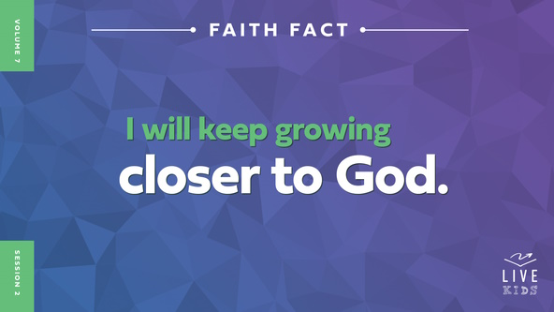

Raise your hand if you want to grow closer to God. *(Group response)* Me too! Let’s say the Faith Fact a few more times together. Since our Bible story today is about seeds and roots, let’s get down low to the ground, touch the floor, and say it. **I will keep growing closer to God**. Each time we say the Faith Fact, we’ll “grow” a little taller as we say it.

• *Lead the kids in saying the Faith Fact a few more times, “growing” taller each time.*

**Game**

**Roots, Stem, or Flower?**

Most living things keep growing and changing in some way. God made plants, animals, and people with the ability to grow. When a plant or flower is healthy, it’s growing. When we have a good and healthy relationship with God, we’re growing in our faith in God.

Today, let’s play a fun game that’s called “Roots, Stem, or Flower.” All three of those options are parts of a growing and healthy flower. For each round, you’ll choose one of those three parts by doing the action that goes with it.

• *Demonstrate the following actions as you share them.*

For roots, bend down and place your hands on the ground. For the stem, stand up straight with your arms tightly against your side. For the flower, lean forward with your hands surrounding your face and your fingers spread wide apart. Let’s practice those actions together a couple times before playing the game.

• *Practice all three actions with the kids a couple of times before moving on.*

Great! I think you’re ready to play. In each round, I’ll turn my back to the group. When I say, “Go,” you’ll do one of those three actions and freeze in place. Next, I’ll choose one action to do and turn around. If you don’t match my action, you’re out of the game and you’ll sit down. Are you ready to play? *(Group response)*

• *Play until someone is the winner.*

• *Play again if you have time.*

• *Optional: Choose a kid to lead the game.*

That was fun! It’s a great reminder to all of us to make sure we’re matching what God wants us to do. We do that by letting God’s Word take root in our life. Listening to what God says to us when we pray and learning what the Bible says can help us grow stronger in God every day.

**Worship**

Worship is another way to help us grow closer to God. When we worship God, we’re inviting Him to speak to us. God wants us to worship Him every single day, but there is something special about worshipping Him together. Let’s sing together as we worship God.

• *Lead the kids in singing one or two praise songs. See suggestions at the beginning of the session.*

**Bible Lesson**

That was an amazing time of worship! Now, it’s time to see what God’s Word tells us about how we can grow deeper and closer to Him. Let’s pray and ask God to help us learn from His Word today.

**Prayer**

|  |
| --- |
| *Dear God, thank You for giving us the opportunity to grow through learning from Your Word today. Help us to learn something new and then live it out. Amen.* |

**Video Intro**

Just before we look at the Bible story, let’s check in with Dash and watch this video.

• *Play* ***Bible Lesson Video****.*

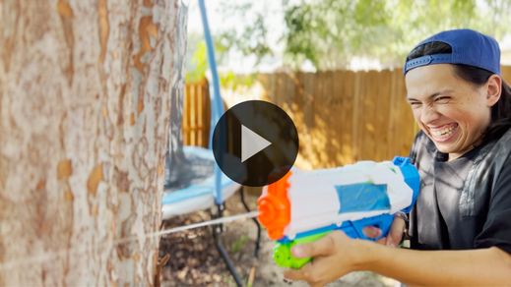

**Bible Story**

**The Parable of the Sower**

That video was a great lead-in to our Bible story today. Dash and his camp friend show us that growing in our faith doesn’t just happen. That’s what today’s Bible story is about. It’s a little different because it’s a story within a story. What do I mean by that? The Bible story we’ll read today is a parable Jesus told to teach the crowd and His disciples. Does anyone know what a parable is? *(Allow responses.)*

A parable is a story about ordinary things but with a spiritual meaning. In our story, Jesus talked about seeds, but there was a deeper, spiritual meaning about those seeds.

Jesus often told parables when teaching the crowds, but He didn’t always explain what His stories meant. Sometimes He would only explain the deeper meaning to His closest followers, His disciples. We have the privilege of knowing what Jesus taught His disciples because the parables’ meanings are included in the Bible. How cool is that!

**Teaching Time**

|  |
| --- |
| ***You Will Need***   * *Bag of sunflower seed kernels (without shells)*   *No prep is needed for this activity.* |

Jesus truly is the best example of many things for all of us! Among the things Jesus was great at was being an incredible storyteller. Large crowds of people would gather to hear Him teach. They might go without food if He taught for a long time, and some would even follow Him from town to town to continue learning from Him.

Can you imagine having the opportunity to hear Jesus teach in person? *(Group response)* I’m sure it was an amazing experience! While we can’t go somewhere to listen to Him speak today, we have the unique opportunity to learn from many of Jesus’ teachings and stories through the Bible. Let’s take advantage of learning from His teaching and not take it for granted. Let’s read one of Jesus’ parables. Grab your Bible or pull up a Bible app on your device. Turn to [Mark 4:1–20](https://ref.ly/logosref/Bible.Mk4.1-20).

• *In order to keep Large Group time moving along, we recommend that the leader reads the Scripture portions aloud.*

• *Optional: Remind the kids to mark this place with their Bible bookmark so they can read it on their own at home.*

**1. Jesus taught the people using a story.**

• *Show the* ***Teaching Point 1 Slide.***

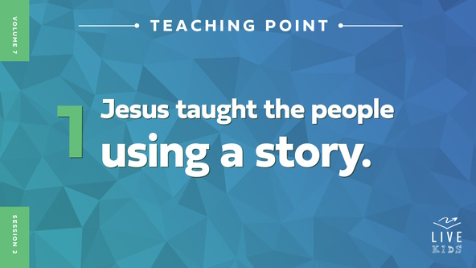

• *Read* [*Mark 4:1–9*](https://ref.ly/logosref/Bible.Mk4.1-9)*.*

Like many times before, a large crowd had gathered around Jesus to hear Him teach. Was Jesus teaching in a church? *(Group response)* No. This time Jesus got into a boat so that everyone could see and hear Him. He began to tell the crowd a parable. Remember, a parable is a story that also shares a spiritual truth. See if you can figure out what Jesus wants us to know from this parable.

This parable was about a farmer who went out to plant seeds in his field. Do you think the people listening to Jesus knew about planting seeds? *(Group response)* They sure did! They didn’t get their food from a store like we have today. They got their food from gardens, fruit trees, and fields filled with plants. If people didn’t grow their own food, they would get it directly from someone who did.

Why would a farmer need to plant seeds? *(Allow responses.)* Right! The farmer’s goal would be to grow vegetables and fruit, and those plants start with seeds. Unfortunately, that isn’t what happened with all the seeds the farmer planted in Jesus’ parable.

• *Show the* ***Teaching Time Slide****. Point to the pictures as you share.*

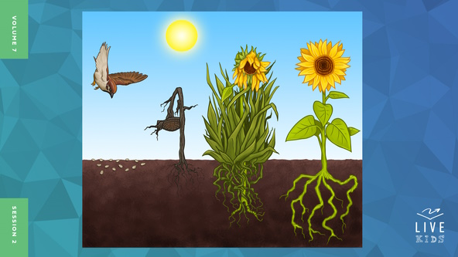

Did all the seeds grow? *(Group response)* No, they didn’t. Some of the seeds were eaten by birds. Some only grew shallow roots and died quickly in the hot sun. Other seeds sprouted into plants but were choked by the thorns that grew up around them. What happened to the seeds that fell on the good soil? *(Allow responses.)*

Not only did those seeds grow, but they produced a crop that had up to a hundred times more seeds than the farmer planted in the first place. *(Hold up bag of sunflower seeds.)* Some plants have even more seeds than that. one little sunflower seed can grow into a big plant with more than two thousand seeds.

• *Optional: Give each kid one or more sunflower seed kernels. You will also do this in Response Time if you prefer to wait.*

• *Be aware of kids with nut allergies. They could be affected by sunflower seeds.*

Jesus ended His story by telling the people to use their ears to listen and understand. Do you think the people had any clue what Jesus meant by His parable? *(Group response)* Many probably didn’t. The story may have sounded to them like a description of a farmer doing his job. After all, planting seeds was something that happened all the time in fields and gardens around them. Farmers would have planted plenty of seed, hoping that some of it would grow.

Remember, Jesus’ story was a parable. That means it had a very important spiritual meaning behind it. Do you think you’ve figured out what it is? *(Group response)* Let’s find out.

**2. Jesus explained the story to His disciples.**

• *Show the* ***Teaching Point 2 Slide.***

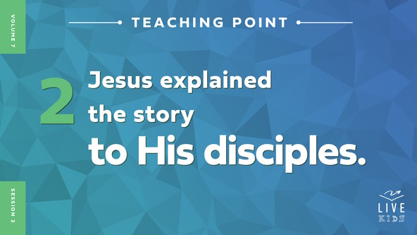

• *Read* [*Mark 4:10–13*](https://ref.ly/logosref/Bible.Mk4.10-13)*.*

Here’s the interesting part about Jesus’ parables. He often didn’t explain them to the large crowds. Sometimes He only shared a parable’s meaning with His closest friends, His disciples. You might think that His disciples would have understood what His parable meant right away, but they had no clue. Later, when they were alone with Jesus, they asked Him what the story meant.

Jesus used the word *secret* when referring to the meaning of this parable. Raise your hand if you’ve ever had a secret. *(Group response)* Do you yell *(yell loudly)* your secrets out for all to hear? *(Group response)* Of course not! You whisper *(whisper)* it quietly to only a few of your closest friends. Secrets aren’t something you and I would share with just anyone because secrets are special. We would want to be sure we can trust the people we tell. Who do you usually tell your secrets to? *(Allow responses.)*

Jesus’ secrets were even more important than our secrets because they were about the kingdom of God. Jesus told His disciples the reason why He shared the meaning of the parables with them. It was to fulfill a very old Scripture from the Old Testament that said people would hear what Jesus taught but not understand it.

Many in the crowd were just like the soils in Jesus’ parable where the seed didn’t take root. They heard Jesus speak God’s Word, but that truth didn’t get into in their life. Like that Old Testament verse said, they heard but didn’t understand.

**3. Jesus’ story teaches us to be rooted in His Word.**

*Show the* ***Teaching Point 3 Slide.***

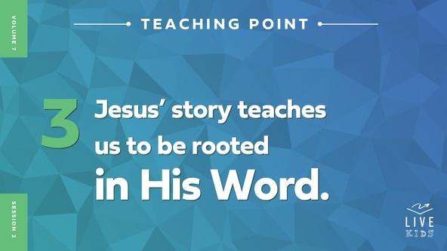

• *Read* [*Mark 4:14–20*](https://ref.ly/logosref/Bible.Mk4.14-20)*.*

Finally, Jesus shared the meaning of this story with His disciples. Every time people hear or read God’s Word, they have a choice to make about how they will respond to what they have heard.

• *Show the* ***Teaching Time Slide*** *again****.*** *Point to the pictures that go with each example below.*



Some people might respond negatively or ignore it. That’s like having Satan swoop in and take the seeds of God’s truth away. Some might respond positively at first, but then right away they forget what they learned or even give up on their faith. That can even happen to us we when don’t pay enough attention to remember what we’ve learned here. Some people might get distracted by other things going on in their life, so they don’t make reading God’s Word a priority. Their time gets choked up by other distractions.

The most important thing we can learn from this parable about the farmer planting seeds is that God wants all of us to let His Word take root in our life. When we hear God’s Word, we need to learn what it means and obey it. When we do that, we can grow into the kind of person God wants us to be. We grow closer to God and our life produces good things.

Let’s do our best to do the right thing every time we read and learn more from God’s Word. Let’s live out our Faith Fact. Say it with me. **I will keep growing closer to God.** When we are close to God and know the truths found in His Word, the problems we face in life will not be able to take us down. We’ll be strong and fruitful.

**Prayer and Response**

*Consider playing a worship song softly in the background while kids pray.*

|  |
| --- |
| ***You Will Need***   * *Sunflower seed kernels, enough to give a small handful to each kid.* * *Optional: Small plastic bags, one per kid*   ***Getting Ready***   * *Optional: Put sunflower seed kernels in a small plastic bag for each kid.* |

• *Hand out a sunflower seed kernel to each kid.*

These seeds are a reminder that you will grow closer to God when you have the seeds of His Word planted in your life. What will you do with that? Will you allow God’s Word to take root in your life by practicing what the Bible teaches, or will you let it be like the other seeds the farmer planted? Let’s pray and ask God to help us grow strong when He plants the seeds of His Word in our life.

**Prayer**

*Optional: Have the kids repeat phrases of the prayer after you.*

|  |
| --- |
| *Dear God, thank You for helping me to understand the meaning of this parable. Help me to love the Bible. I want to be rooted deeply in Your Word and grow closer to You every day. Amen.* |

**Faith Verse**

Our Faith Verse reminds us how we can stay rooted and stand firm when we face hard times. Our Faith Verse is found in [Ephesians 6:13](https://ref.ly/logosref/Bible.Eph6.13). Let’s say our Faith Verse and do the actions together.

• *Play* ***Faith Verse Video****.*

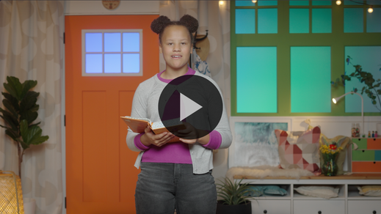

[Ephesians 6:13](https://ref.ly/logosref/Bible.Eph6.13) (NLT)

Put on every piece of God’s armor so you will be able to resist the enemy in the time of evil. Then after the battle you will still be standing firm.

When we put on God’s armor, we’re choosing to plant ourself in our faith in God. Remember, the sword in God’s armor represents the Bible. Let’s use our sword every day to face our battles head-on.

**Faith Fact**

Before we go to our small groups, let’s say our Faith Fact again. **I will keep growing closer to God.**

• *Show the* ***Faith Fact Slide****.*



Let’s say our Faith Fact together and stomp our feet as if we are planting our feet in God’s Word. **I will keep growing closer to God.** Remember to keep growing closer to God this week by planting yourself in His Word, the Bible.

• *Dismiss kids to Small Group time or to go home if your group time ends here.*

**Small Group**

**30 Minutes**

*This section can be done in conjunction with the large group or on its own if you do small groups with your kids. During Small Group time, the goal is to connect the kids with the Word of God and to each other. All activities are led by the small group leader.*

**Group Connection**

**Plant, Plant, Grow!**

We can all learn more from God’s Word, but what we do with it is what really matters. If God’s Word is planted in our life and allowed to grow, we will grow closer to God. He will help us remain rooted in Him through any difficult time we might face. Let’s play a game about Jesus’ parable that’s called “Plant, Plant, Grow.” Here’s how we’ll play.

• *Have the kids sit in a circle.*

One person will be the farmer and walk around the circle. The farmer will tap each person lightly on the head and say, “Plant,” as they go around the circle. Then, the farmer will pick someone and say, “Grow!”

If you’re the person who is chosen to grow, you’ll jump up and chase the farmer around the circle. If you tag the farmer before they make it to your spot, you get to choose who is the farmer for the next round. If you don’t tag them, you’re the farmer for the next round. Who’s ready to play? *(Group response)*

• *Keep playing until most of the kids have been the farmer or until you run out of time.*

Some of you were really quick to react. You were ready to grow! Allowing God’s Word to be planted in our life is just the first step to growing. We must choose to keep growing closer to God as we do what His Word says.

**Bible Lesson Recap**

• *If small group activities are not immediately following large group time, you may want to read the Bible story passage before the discussion.*

|  |
| --- |
| ***You Will Need***   * *Bibles for kids in the group to share*   *No prep needed for this activity.* |

**Bible Story Review: The Parable of the Sower** [**Mark 4:1–20**](https://ref.ly/logosref/Bible.Mk4.1-20)

Sometimes Jesus taught crowds of people using parables or stories that have a deeper, spiritual meaning. He didn’t always share the secret meaning behind His parables with the large crowds. For the parable about the farmer and the seeds, Jesus shared the meaning with His closest disciples. Thankfully, all of us get to learn about it because God had it written down in the Bible.

The farmer planted seeds in a field hoping they would grow into healthy plants. Sadly, many of the seeds the farmer planted didn’t take root and grow as he had hoped they would. But, the seed that fell on good ground grew to produce much more than the farmer had planted. The meaning of Jesus’ parable was to teach us the importance of allowing the seed of God’s Word to take root in our life. Then, we can continue to grow closer to God.

• *Give each kid a Bible and read the Bible story together.*

**Group Discussion**

*Feel free to use all or just a few questions as a jumping-off place for good discussion. Questions marked with * are designed for more conversation. Adjust the questions based on the age or maturity of your group. Typically, older kids will be able to dive a little deeper than younger ones.*

**Questions**

Why do you think Jesus taught the people using parables?

Why do you think Jesus used this example of a farmer planting seeds to teach the people?

* Sometimes we learn things from the Bible, but we don’t always grow. Raise your hand if any of these describe you.

• You like learning from the Bible.

• Sometimes it’s hard for you to remember what you’ve learned from the Bible.

• Someone has told you that the Bible isn’t true.

• You have memorized one or more verses from the Bible.

• You want to read the Bible more, but it can be hard to find the time.

• You try hard to grow closer to God by remembering what you learn from the Bible.

* How can we grow closer to God?

* What are some ways that others can see that you are planted in God’s Word?

* Who has planted the seeds of God’s Word in your life? How has that person helped you to grow?

**Live It**

**Faith Fact**

We can all get better at letting God’s Word grow in us. Let’s say our Faith Fact as a reminder. **I will keep growing closer to God.** Raise your hand if you want to grow closer to God every day. *(Group response)*

**Challenge**

Like a farmer needs to take care of his seeds every day to help them grow, we need to spend time with God regularly. We can’t just read the Bible to check it off our list for the day. We need to spend time with God, asking Him to speak to us personally like the disciples asked Jesus to explain what His parable meant. Every time you read your Bible this week, ask God what He wants you to learn from what you have read. Then pause and listen for Him to speak to you. God wants to grow closer to you, and He wants you to grow closer to Him.

**Prayer**

*Finish group discussion by sharing prayer requests and praise reports. Keep track of your small group’s prayer requests and review them each time you meet.*

• *Have kids share and pray for each other’s prayer requests.*

|  |
| --- |
| *Dear God, we need You to help us to do more than just read Your Word. Help us to let Your Word speak to us so we can grow closer to You. Amen.* |

**Faith Verse Review**

|  |
| --- |
| ***You Will Need***   * ***Small Group Faith Verse Review****, one set per group* * *Colored paper in flower colors: yellow, pink, light blue, light purple, etc.* * *Floor-safe tape* * *Permanent marker* * *Small paper plates, one per group* * *Whiteboard* * *Dry-erase markers*   ***Getting Ready***   * *Print the* ***Small Group Faith Verse Review*** *on the flower colored paper, one set per group.* * *Cut apart the Faith Verse petals.* * *Tape the Faith Verse petals on a wall out of easy reach of kids so they have to jump to get one.* * *Write “*[*Ephesians 6:13*](https://ref.ly/logosref/Bible.Eph6.13)*” on the back of the plate. The plate will be the center of the flower.* * *Optional: Write the Faith Verse on the whiteboard to help kids complete the game.* |

One of the reasons that some seed didn’t grow in Jesus’ parable was when birds swept in and took them. Jesus said the birds represented our enemy, Satan. Our Faith Verse [Ephesians 6:13](https://ref.ly/logosref/Bible.Eph6.13) is a reminder to use God’s armor to keep the enemy away. Let’s continue learning our Faith Verse and its actions together.

• *Show* ***Faith Verse Video****.*



[Ephesians 6:13](https://ref.ly/logosref/Bible.Eph6.13) (NLT)

Put on every piece of God’s armor so you will be able to resist the enemy in the time of evil. Then after the battle you will still be standing firm.

Let’s say it together a couple of more times. I hope that you are starting to memorize this powerful verse even though it’s pretty long. Let’s allow it to take root in our lives.

• *Say the verse as a group a couple of times.*

**Faith Verse Fun**

**Faith Verse Flower Relay**

Let’s have some fun practicing the Faith Verse. First, you need to line up from tallest to shortest.

• *Help kids get into a line by height.*

Since we’ve talked about growing plants today, we’ve got the Faith Verse words on flower petals. *(Point to where they are.)* When it’s your turn, your job is to run down and get the highest petal you can reach. Then, you’ll hurry back so the next kid can go. The goal is to put the petals in the correct order of the Faith Verse to form a flower around the plate. Let’s go!

• *Place the plate on a table or the floor.*

• *Let kids play the game. Celebrate when they are finished.*

Great job creating the Faith Verse flower together! Keep practicing the Faith Verse on your own this week and ask God to help it take root in your life.

**Activity Page**

**Finish the Picture**

|  |
| --- |
| ***You Will Need***   * ***Small Group Activity Page****, one per kid* * *Pencils, one per kid* * *Crayons or markers*   ***Getting Ready***   * *Print copies of the* ***Small Group Activity Page****, one per kid.* |

In His parable, Jesus described what happened to the seeds the farmer planted.

• *Hand out a copy of the* ***Small Group Activity Page****, a pencil, and crayons to each kid.*

Hmm. Some things are missing in each of these pictures. Finish the pictures to match what the Jesus said in His parable. Color the pictures when you’re done.

• *Give kids time to complete the* ***Small Group Activity Page.***

**Dismissal**

Jesus taught some incredible truths through the parables He told people. Through His parable about a farmer planting seeds, we learned the importance of planting God’s Word deep in our life. Let’s pray and ask God to help us grow closer to Him as we spend time in His Word.

**Prayer**

|  |
| --- |
| *Dear God, thanks for allowing us to know the meaning of the parables Jesus taught. We pray that the seeds that have been planted in our life today would grow deep roots. Help us grow closer to You each day. Amen.* |

**Faith Fact Recap**

• *Show the* ***Faith Fact Slide****.*



Standing firm requires us to be rooted in the right things. That determines how strong we will be when thorns and the enemy come our way. Remember today’s Faith Fact as you go about your week. Let’s say it together. **I will keep growing closer to God.** I can’t wait to see you again next time.

• *Send home the* ***Small Group Activity Page*** *and the bag of sunflower seed kernels****.***

• *Remind parents that there are* ***Family Devotions*** *available on the app to do with their kid.*

• *Tell everyone the date and time for the next session.*